# 4.0 CHAPTER IV: SYSTEM DESIGN

## 4.1 Introduction

System design is the process of defining the architecture, components, modules, interface, and data for a system to satisfy specified requirements. System design is very important during the early stage of the project. A proper plan must be planned to ensure that all the requirements are met.

System architecture is the fundamental and unifying system structure defined in terms of system elements, interfaces, processes, constraints and behaviors. System architecture also acts as a skeleton of system that helps to explain consistently and design efficiently complex system. System architecture is important in developments of software projects. This is because it able to provide guidance and structure to the later phase of system design and also provide a way to address the alternate form of system, substructure and module, and also complexity of system. Besides, it also may provide some clues to emergent behavior. Furthermore, system architecture also provides simpler way to understand complex system.

Database design also importance in development a software project. Database design is the structure that a database uses to plan, store and manage the transaction data. A good database design is required in ensuring the consistent of data, elimination of data redundancy, efficient execution of queries and high performance application. In addition, a well-designed database is able to ensure the ease of access, retrieval of information and also the safety of data.

## 4.2 System Architecture

The diagram below shows the flow and the architecture of the application.



## 4.3 Database Design

4.3.1 Entity Relationship Diagram(ERD)  
An entity relationship diagram (ERD) shows the relationships of entity sets stored in a database. The diagram below shows connection between each table and the relationship between each table.

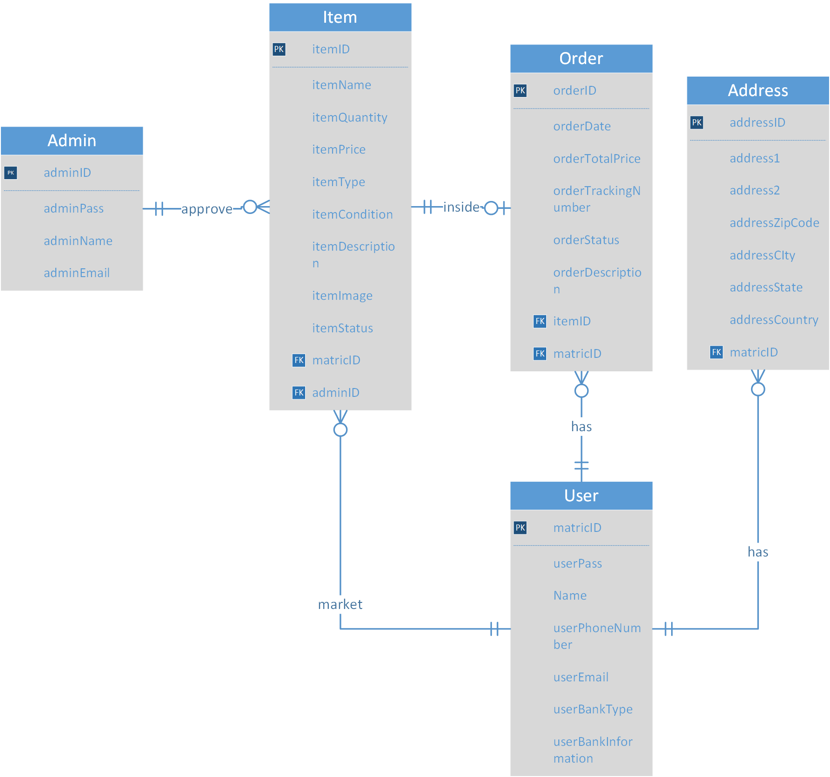

Diagram 1a: ERD diagram

## 4.3.2 Data Dictionary

This table includes the details of the attribute in the table admin. Admin table has 4 attributes that are adminID, adminPass, adminName & adminEmail. adminID is used to specify a uniqueness of the admin. adminPass is the password used to login into the UTeM Market Place admin site. adminName used to specify the name of the admin. adminEmail is the username used to login into the UTeM Market Place admin site.

|  |  |  |  |  |  |  |  |  |
| --- | --- | --- | --- | --- | --- | --- | --- | --- |
| TABLE NAME | ATTRIBUTE NAME | CONTENTS | TYPE | FORMAT | RANGE | REQUIRED | PK OR FK | FK REFERENCED TABLE |
| ADMIN | adminID | Admin unique code | VARCHAR (10) | XXXXXXXXXX | NA | Y | PK |  |
|  | adminPass | Admin’s password | VARCHAR (15) | XXXXXXXX | NA | Y |  |  |
|  | adminName | Admin’s name | VARCHAR (45) |  |  |  |  |  |
|  | adminEmail | Admin’s email  Used to login into admin site | VARCHAR (45) | Xxxxxxxxx@xxxx.com | NA | Y |  |  |

Table 1a: admin table

This table includes the details of the attribute in the table user. User table has 7 attributes that are matricID, userPass, Name, userPhoneNumber, userEmail, userPhoneNumber, userEmail, userBankInformation & userBankType. matricID is the unique number owned by UTeM’s students and staffs. userPass is the password used to login into the UTeM Market Place user site. Name is the name of the user. userPhoneNumber is the user’s contact number. userEmail is the user’s contact email. userBankInformation is the user’s bank account number. userBankType is the user’s bank which is related with the user’s bank account number provided.

|  |  |  |  |  |  |  |  |  |
| --- | --- | --- | --- | --- | --- | --- | --- | --- |
| TABLE NAME | ATTRIBUTE NAME | CONTENTS | TYPE | FORMAT | RANGE | REQUIRED | PK OR FK | FK REFERENCED TABLE |
| USER | matricID | User’s Matric number | VARCHAR (10) | XXXXXXXXXX | NA | Y | PK |  |
|  | userPass | User’s password | VARCHAR (30) | XXXXXXXX… | NA | Y |  |  |
|  | Name | User’s name | VARCHAR (45) | Xxxxxxxxxxxxx… | NA | Y |  |  |
|  | userPhoneNumber | User’s phone number | VARCHAR (15) | Xxxxxxxxxxxxx… | NA | Y |  |  |
|  | userEmail | User’s email | VARCHAR (45) | Xxxxxxxxxxxxx… | NA | Y |  |  |
|  | userBankInformation | User’s bank account number | VARCHAR (20) | Xxxxxxxxxxxxx… | NA | Y |  |  |
|  | userBankType | User’s bank which is related to the user’s bank account | VARCHAR (20) | Xxxxxxxxxxxxx… | NA | Y |  |  |

Table 1b: user table

This table includes the details of the attribute in the table address. Address table has 7 atrributes that are addressID, address1, addressZipCode, addressCity, addressState, addressCountry, matricID & addressID is the unique code for every address. address1 is the user’s address without zip code, city name, state name and country. addressZipCode is the zip code of the user’s address. addressCity is the city of the user’s address. addressState is the state of the user’s address. addressCountry is the country of the user’s address. matricID is the user’s matric id which is used to identified the address is own by which user.

|  |  |  |  |  |  |  |  |  |
| --- | --- | --- | --- | --- | --- | --- | --- | --- |
| TABLE NAME | ATTRIBUTE NAME | CONTENTS | TYPE | FORMAT | RANGE | REQUIRED | PK OR FK | FK REFERENCED TABLE |
| ADDRESS | addressID | Address’s id | INT (10) | XXXXXXXXXX | NA | Y | PK |  |
|  | address1 | User’s address information which include house number and street | VARCHAR (150) | Xxxxxxxxxxxxx… | NA | Y |  |  |
|  | addresZipCode | Zip Code of the Address | VARCHAR (5) | XXXXXXXXXX | NA | Y |  |  |
|  | addressCity | City of the Address | VARCHAR (20) | XXXXXXXXXX | NA | Y |  |  |
|  | addressState | State of the Address | VARCHAR (20) | XXXXXXXXXX | NA | Y |  |  |
|  | addressCountry | Country of the Address | VARCHAR (15) | XXXXXXXXXX | NA | Y |  |  |
|  | matricID | Matric number of the user | VARCHAR (10) | XXXXXXXXXX | NA | Y | FK | USER |

Table 1c: address table

This table includes the details of the attribute in the table order. Order table has 8 attributes that are orderID, orderDate, orderTotalPrice, orderTrackingNumber, orderStatus, orderDescription, itemID, matricID & orderID is the unique number of the order. orderDate is the date of the order confirmed. orderTotalPrice is the total price of the order. orderTrackingNUmber is the tracking number of the order. orderStatus is the status of the order. orderDescription is the description of the order. itemID used to identify what item is inside the order. matricID used to identify who make the order.

|  |  |  |  |  |  |  |  |  |
| --- | --- | --- | --- | --- | --- | --- | --- | --- |
| TABLE NAME | ATTRIBUTE NAME | CONTENTS | TYPE | FORMAT | RANGE | REQUIRED | PK OR FK | FK REFERENCED TABLE |
| ORDER | orderID | Order code | INT (11) | XXXXXXXXXX | NA | Y | PK |  |
|  | orderDate | Date of order | DATE | DD-MON-YYYY | NA | Y |  |  |
|  | orderTotalPrice | Total price of order | DOUBLE (6,2) | ####.## | 0.00-9999.00 | Y |  |  |
|  | orderTrackingNumber | Tracking number of order | VARCHAR (20) | XXXXXXXXXXXX | NA | Y |  |  |
|  | orderStatus | Status of order | VARCHAR (10) | XXXXXXXXXX | NA | Y |  |  |
|  | orderDescription | Description of order | VARCHAR (15) | Xxxxxxxxxxxxx… | NA | Y |  |  |
|  | itemID | Item code | INT (11) | XXXXXXXXXX | NA |  | FK | ITEM |
|  | matricID | Matric number | VARCHAR (10) | XXXXXXXXXX | NA |  | FK | USER |

Table 1d: order table

This table includes the details of the attribute in the table item. Item table has 11 attributes that are itemID, itemName, itemQuantity, itemPrice, itemType, itemCondition, itemDescription, itemImage, itemStatus, matricID & adminID. itemID is the unique code of the item. itemName is the name of the item. itemQuantity is the quantity of the item. itemPrice is the price of the item. itemType is the type of the item. itemCondition is the condition of the item. itemDescription is the description of the item. itemImage is the image path of the item. itemStatus is the status of the item. matricID used to identify who selling this item. adminID used to identify allowed the item to searchable by user.

|  |  |  |  |  |  |  |  |  |
| --- | --- | --- | --- | --- | --- | --- | --- | --- |
| TABLE NAME | ATTRIBUTE NAME | CONTENTS | TYPE | FORMAT | RANGE | REQUIRED | PK OR FK | FK REFERENCED TABLE |
| ITEM | itemID | Item code | INT (11) | XXXXXXXXXX | NA | Y | PK |  |
|  | itemName | Item name | VARCHAR (45) | Xxxxxxxxxxxxx… | NA | Y |  |  |
|  | itemQuantity | Quantity of item | INT (3) | ### | 0-999 | Y |  |  |
|  | itemPrice | Price of item | DOUBLE (6,2) | ####.## | 0.00-9999.00 | Y |  |  |
|  | itemType | Type of item | VARCHAR (10) | XXXXXXXXXX | NA | Y |  |  |
|  | itemCondition | Condition of item | VARCHAR (10) | XXXXXXXXXX | NA | Y |  |  |
|  | itemDescription | Description of item | VARCHAR (100) | Xxxxxxxxxxx… | NA |  |  |  |
|  | itemImage | Image path of item | VARCHAR (10) | XXXXXXXXXX | NA | Y |  |  |
|  | itemStatus | Status of item | VARCHAR (100) | XXXXXXXXXX… | NA | Y |  |  |
|  | matricID | Matric number | VARCHAR (10) | XXXXXXXXXX | NA | Y | FK | USER |
|  | adminID | Admin unique code | VARCHAR (10) | XXXXXXXXXX | NA |  | FK | ADMIN |

Table1e: item table

## 4.4 Module Integration and Interface Design

Implementation of the UTeM Market Place is an application which is in android platform. The following diagram shows the implementation of the system into the application as a prototype.

Login Page

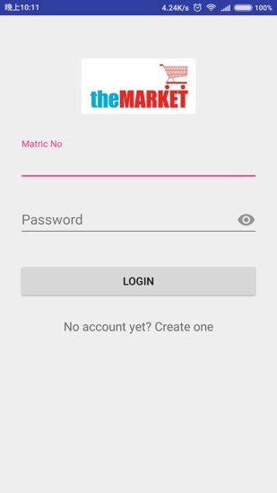

Diagram 3.1 login page

Main page

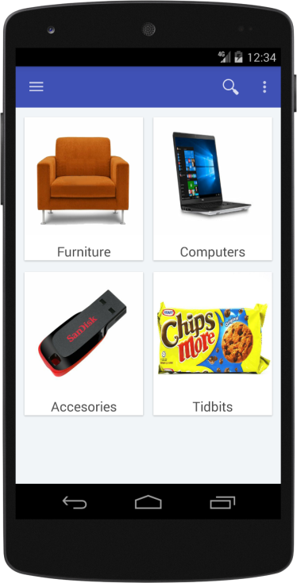

Diagram 3.2 Main page

Search item Page

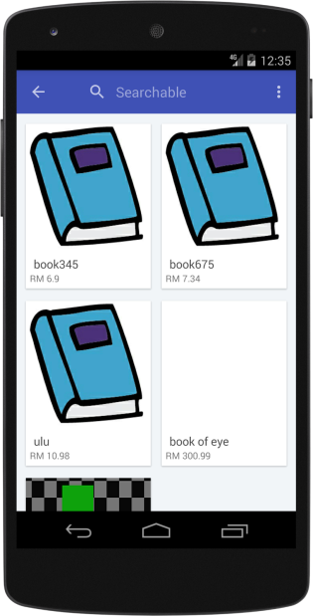

Diagram 3.3 Search item Page diagram

View Item Details

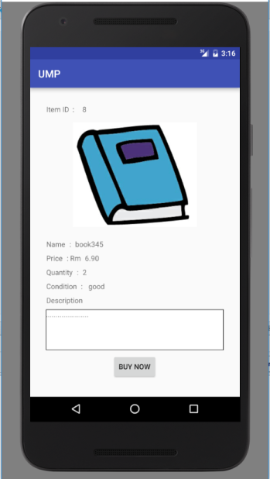

Diagram 3.4 view item details diagram

Purchasing Page

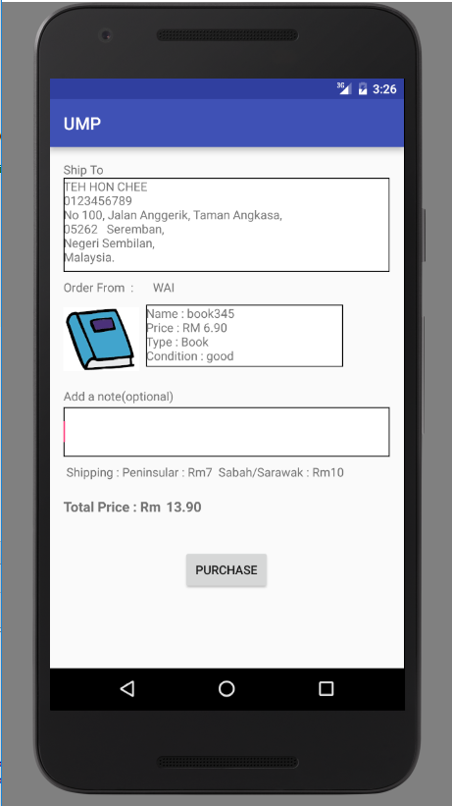

Diagram 3.5 Purchasing page diagram

Order Page

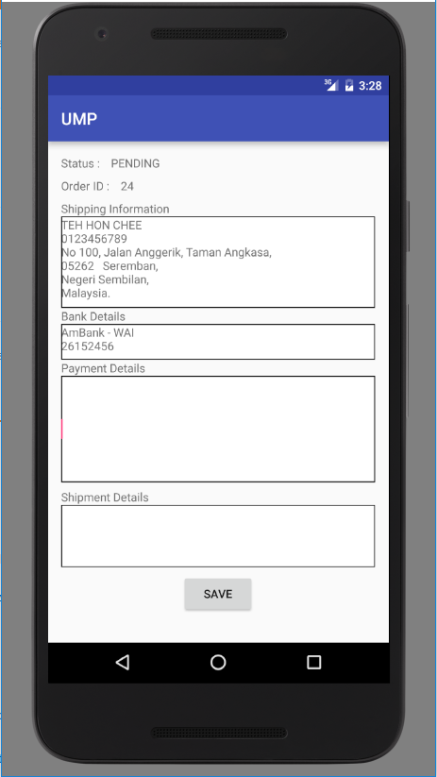

Diagram 3.6 Order page diagram

Sell item page

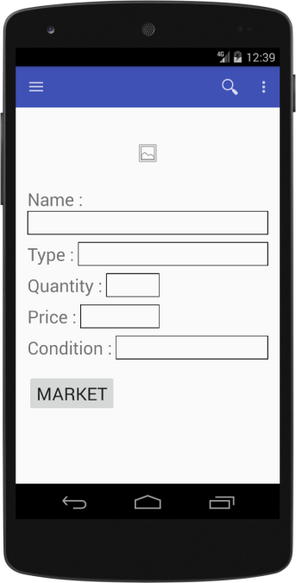

Diagram 3.7 sell item page diagram

Update item Page

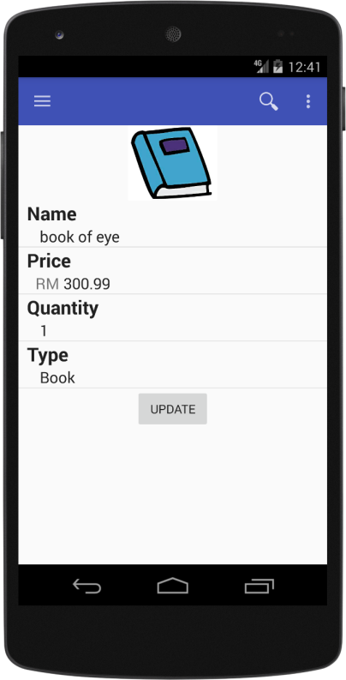

Diagram 3.8 update item page diagram

## 4.5 System Design

### 4.5.1 Sequence Diagram

#### 4.5.1.1 Authenticate Module

Authenticate module has 2 functions that allow user signup as an authorized user and allow authorized user accesses to UTeM Market Place.

* + 1. Signup Function  
       This function allows UTeM students and staffs to become an authorized user to access into the application.  
       Sequences Diagram:

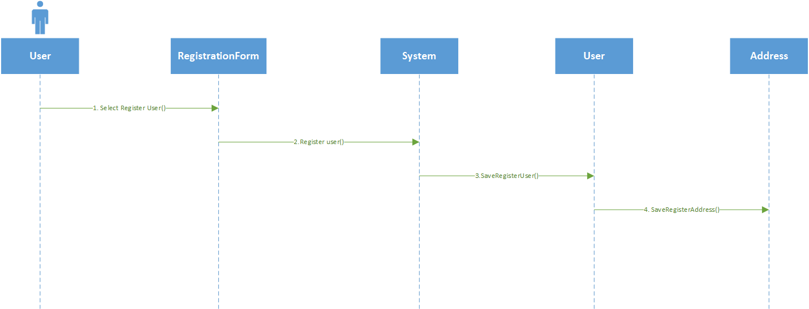

Diagram 2.1.a.1 signup sequence diagram

Class diagram:

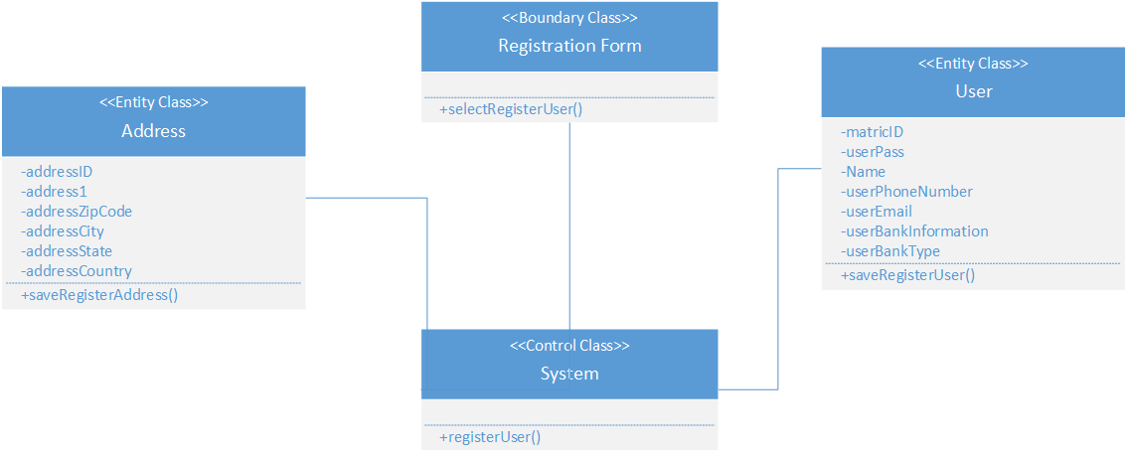

Diagram 2.1.a.2 signup class diagram

ii. Login Function  
This function allows authorized user to access into UTeM Market Place and able to prevent unauthorized user to access into the application.  
Sequence Diagram:

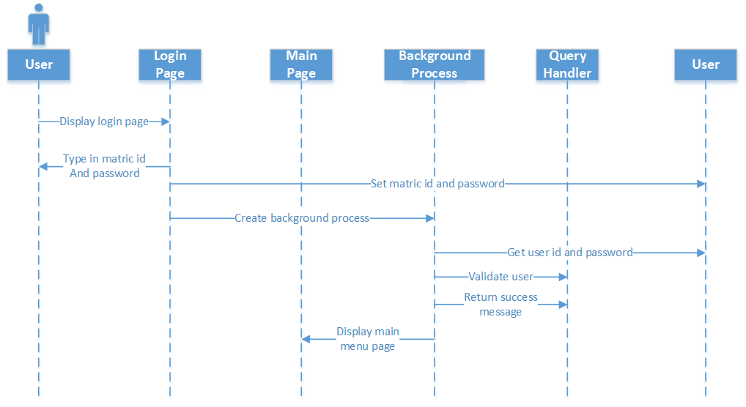

Diagram 2.1.b.1 login sequence diagram

Class Diagram:

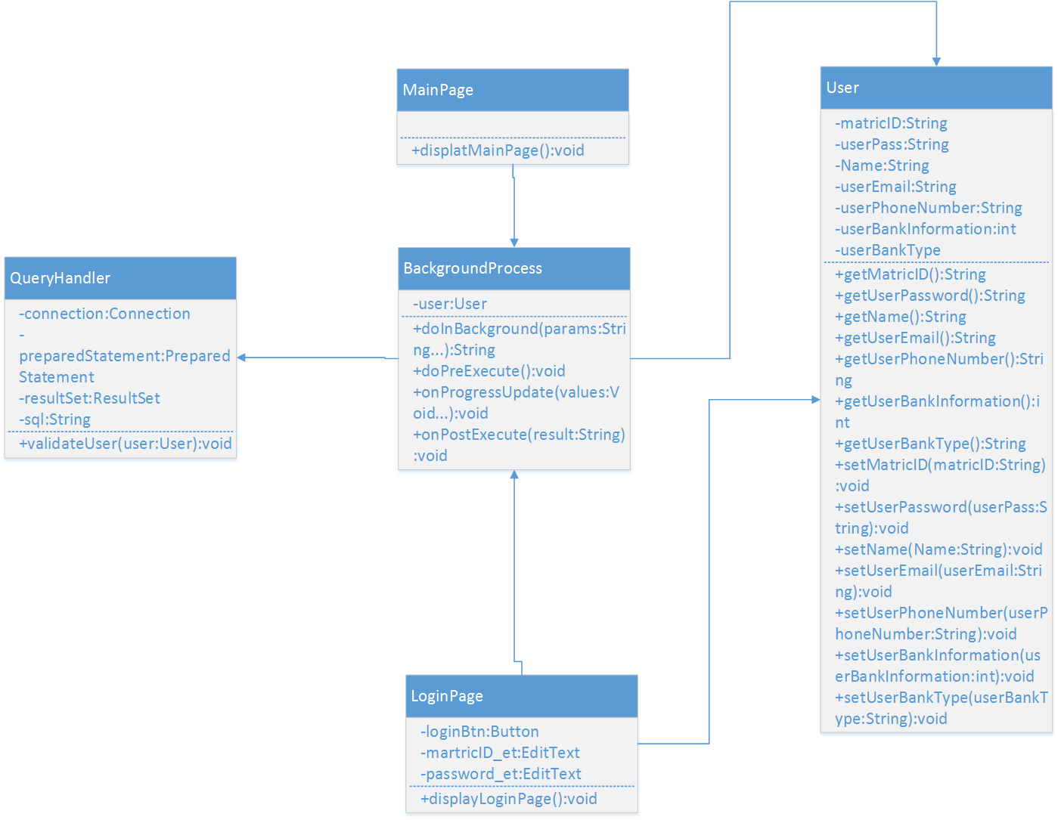

Diagram 2.1.b.2 login class diagram

### 4.5.1.2 Administrator Module

Admin module has 2 functions that allow admin to approve a pending item that are to be market and update admin’s account information.

i. Approve item Function  
This function allows admin to approve pending item. Admin change the status of the item from pending to either approve or unapproved.  
Sequence Diagram:

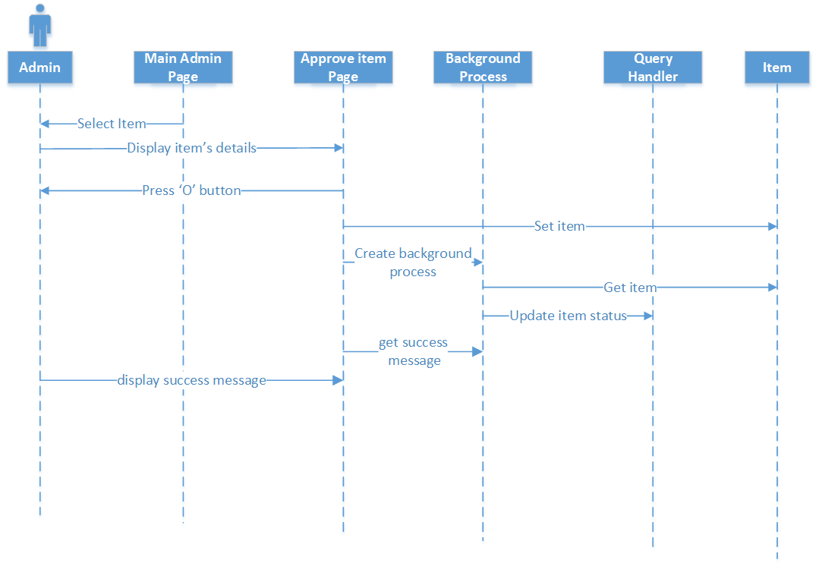

Diagram 2.2.a.1 approve item sequence diagram

ii. Update admin’s account information Function  
This function allows admin to update him/herself account details. Admin open the account page and edit the desired field then press update button to update their account details.  
Sequence Diagram:

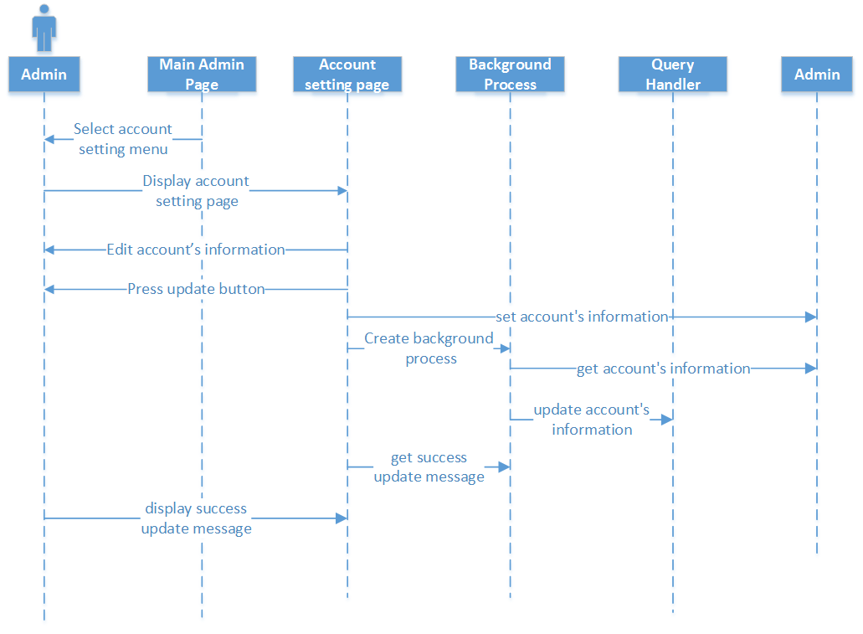

Diagram 2.2.b.1 update admin account sequence diagram

iii. Overall Class diagram:

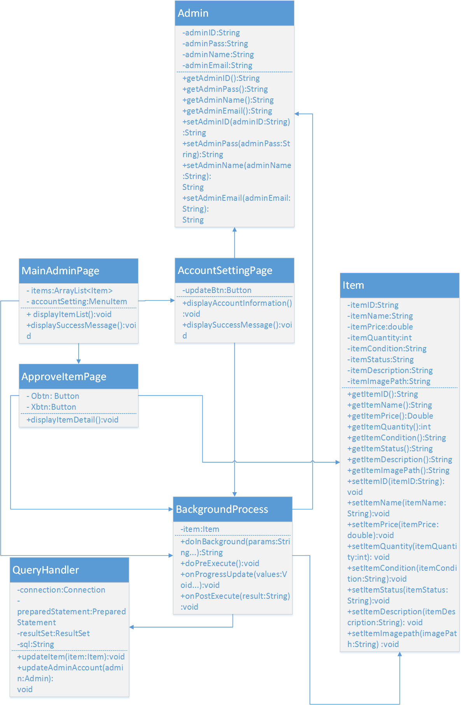

Diagram 2.2.c.1 admin module overall class diagram

#### 4.5.1.3 User Module

User module has 1 function that is allow user to view, add, update and delete user’s account information.

* + 1. View, add, update and delete function.  
       User able to open the account detail page and edit his/herself account information.  
       Sequence Diagram:

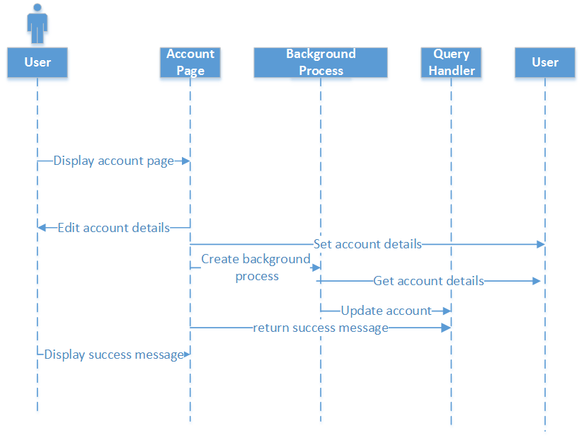

Diagram 2.3.a.1 view, add, update & delete user sequence diagram

Class Diagram:

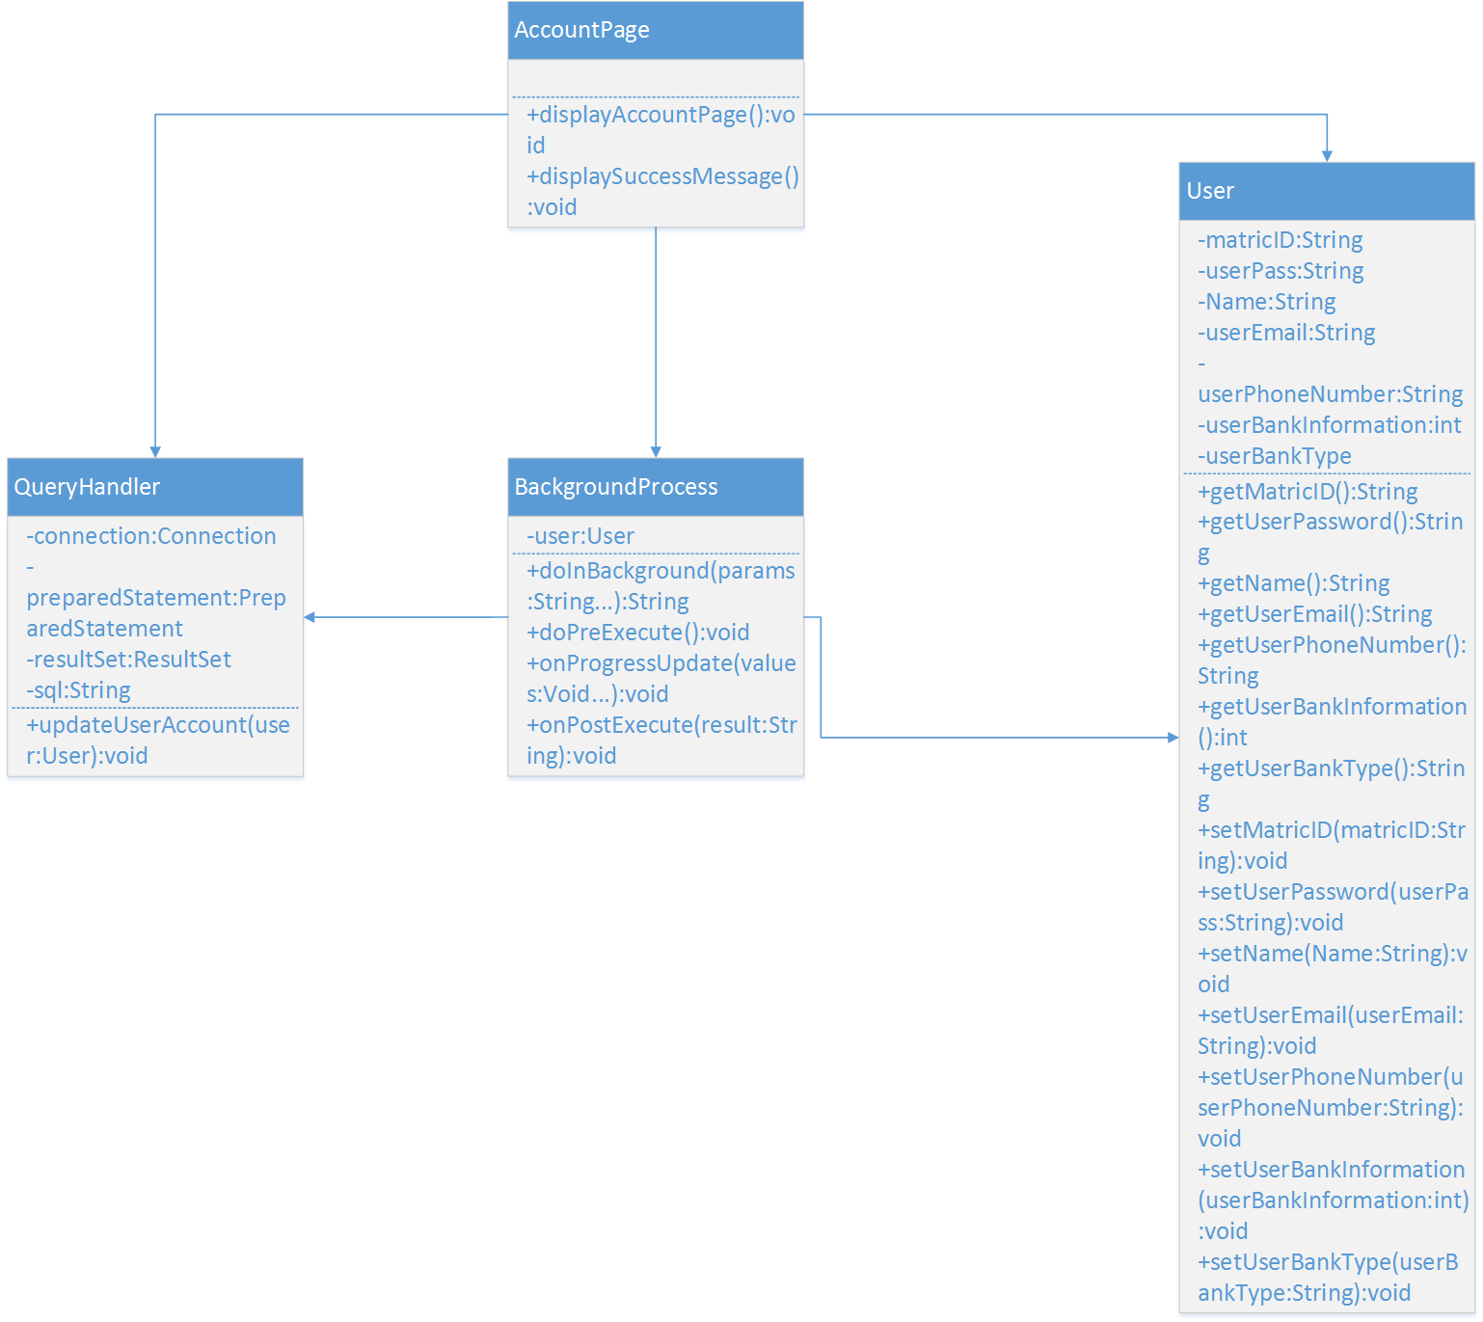

Diagram 2.3.a.1 view, add, update & delete user class diagram

### 4.5.1.3 Market Module

Market module has 4 functions that allow user to sell an item, allow seller to view, update and delete items that are currently marketing by him/herself, allow user to view an item that is currently marketing and allow user to buy an item.

i. Sell item Function  
This function allow user to sell an item in UTeM Market Place. User required to fill in the required field and press button as a procedure to sell an item. UTeM Market Place will gather the item’s information and save into the database for further use.  
Sequence diagram:

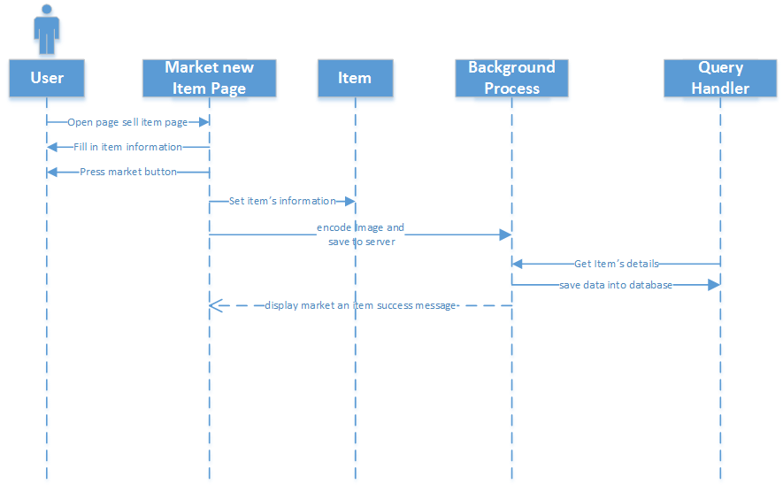

Diagram 2.4.a.1 sell item sequence diagram

Class diagram:

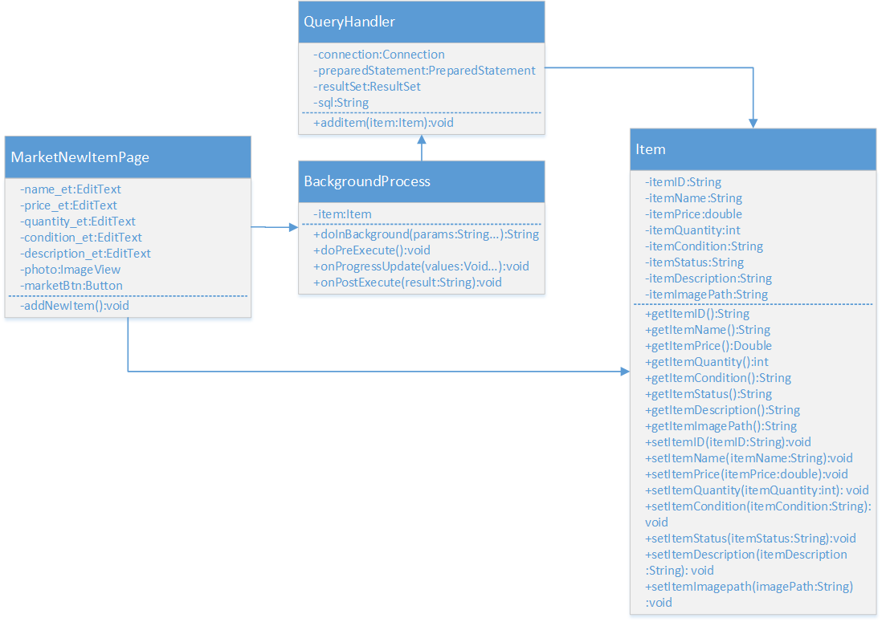

Diagram 2.4.a.2 sell item class diagram

ii. View, update and delete item Function  
This function allow user to monitor the item marketed by the user him/herself, update the items which is marketed by the user him/herself and delete the item that is currently marketing in the UTeM Market Place. The procedure to do so is user open the marketed item list in UTeM Market Place to view or monitor the item then user could either delete the item from UTeM Market Place or update the item’s information.  
Sequence diagram:

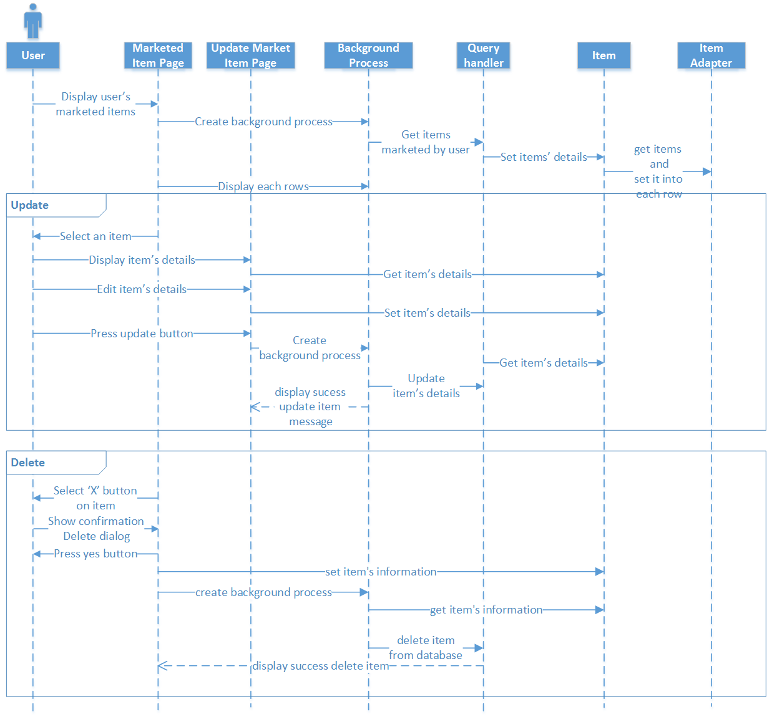

Diagram 2.4.b.1 View, update and delete item sequence diagram

Class diagram:

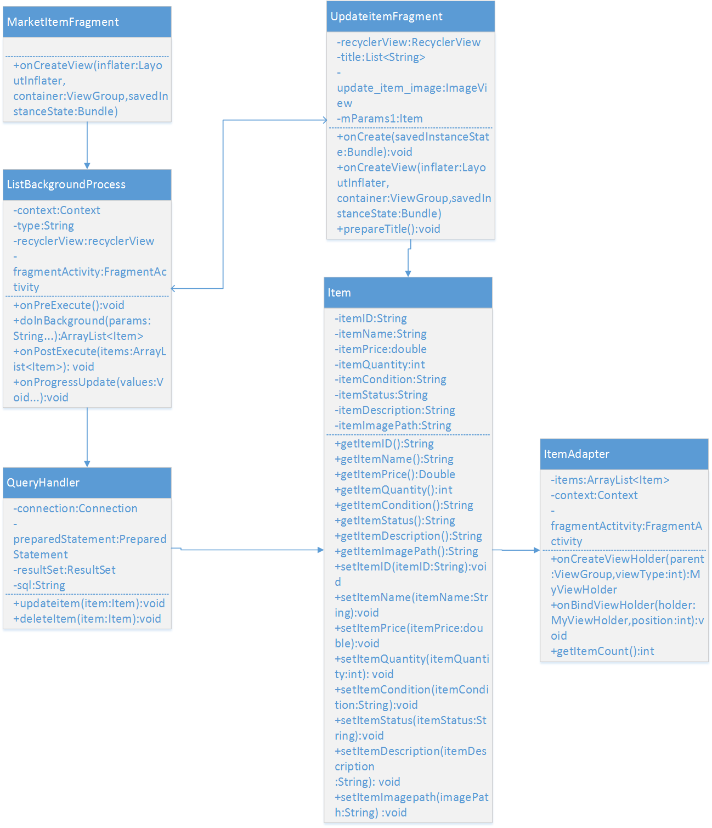

Diagram 2.4.b.2 View, update and delete item class diagram

* 1. View and buy item Function  
     User able search for an item and then view the item’s details. Next user could buy an item and the application will generate an order.  
     Sequence Diagram:

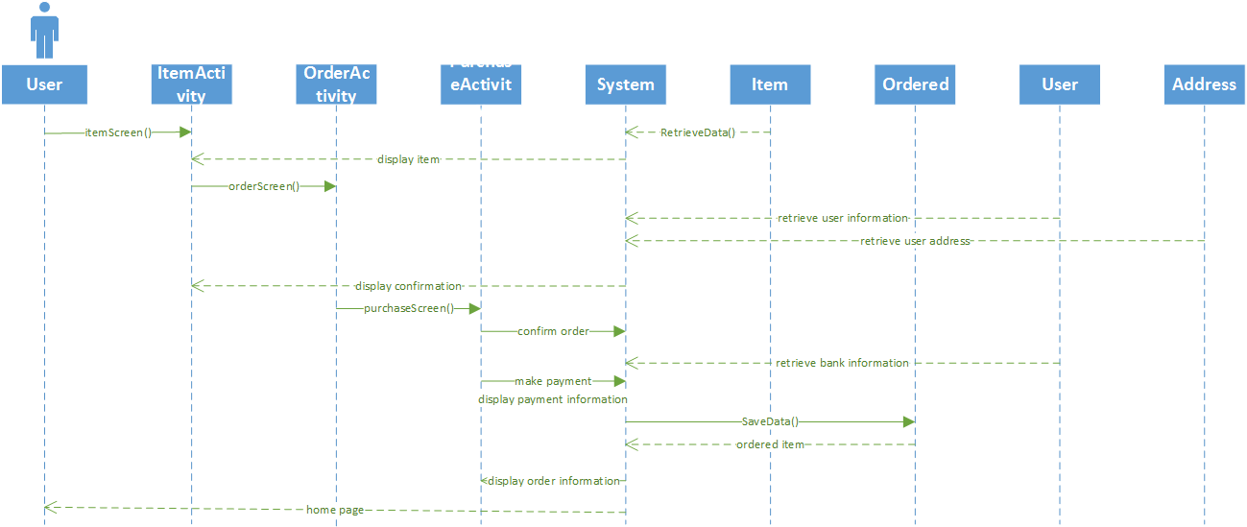

Diagram 2.4.c.1 View and buy item sequence diagram

Class diagram:

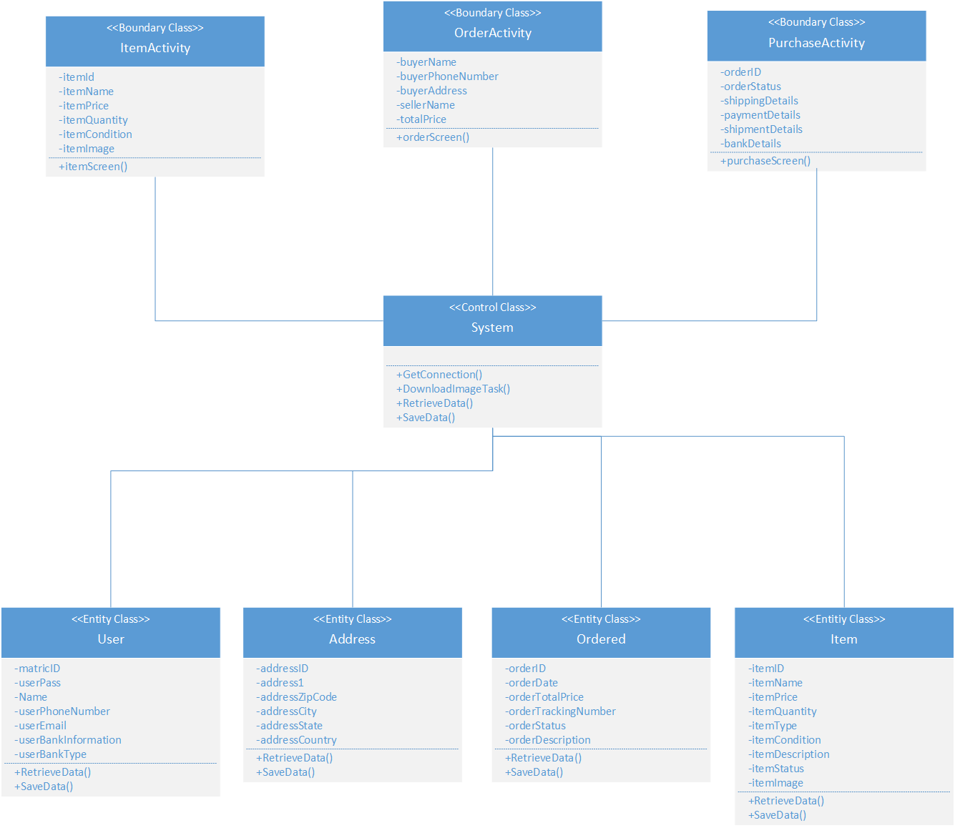

Diagram 2.4.c.2 View and buy item class diagram

## 4.5.2 Flow Chart

**C:\Users\Hasnatul\Documents\Education\Sem V (September 2016-February 2017)\Workshop II\application.png**

## 4.6 Conclusion